Curious George
Validate what is happening for the child for example “Gosh this looks really tough for you right now.”
I can see that you are…. (name a physical or somatic response for example crying)
I am wondering if you are … (name an emotion to tame the emotion, never shame it)
How come? (this can be to expand on both positive and negative emotions for example “Wow you tidied your room how come?”)
What/who helped you manage this today? (Focus on coping and managing strategies)
Next time what would make this better?

P.A.C.E. Dan Hughes
Playfulness | Acceptance | Curiosity | Empathy
Playful approaches using gentle humour. | Acceptance of the child’s inner world. | Be curious about the meaning of the child’s behaviour. | 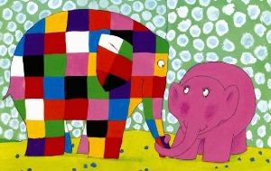  Empathy for the child’s emotional state.

Further information:
Solution Focused Toolkit
https://learning.nspcc.org.uk/media/1073/solution-focused-practice-toolkit.pdf
Dan Hughes Trauma Informed Approach
https://girfec.fife.scot/wp-content/uploads/sites/61/2020/06/PACE-School.pdf

